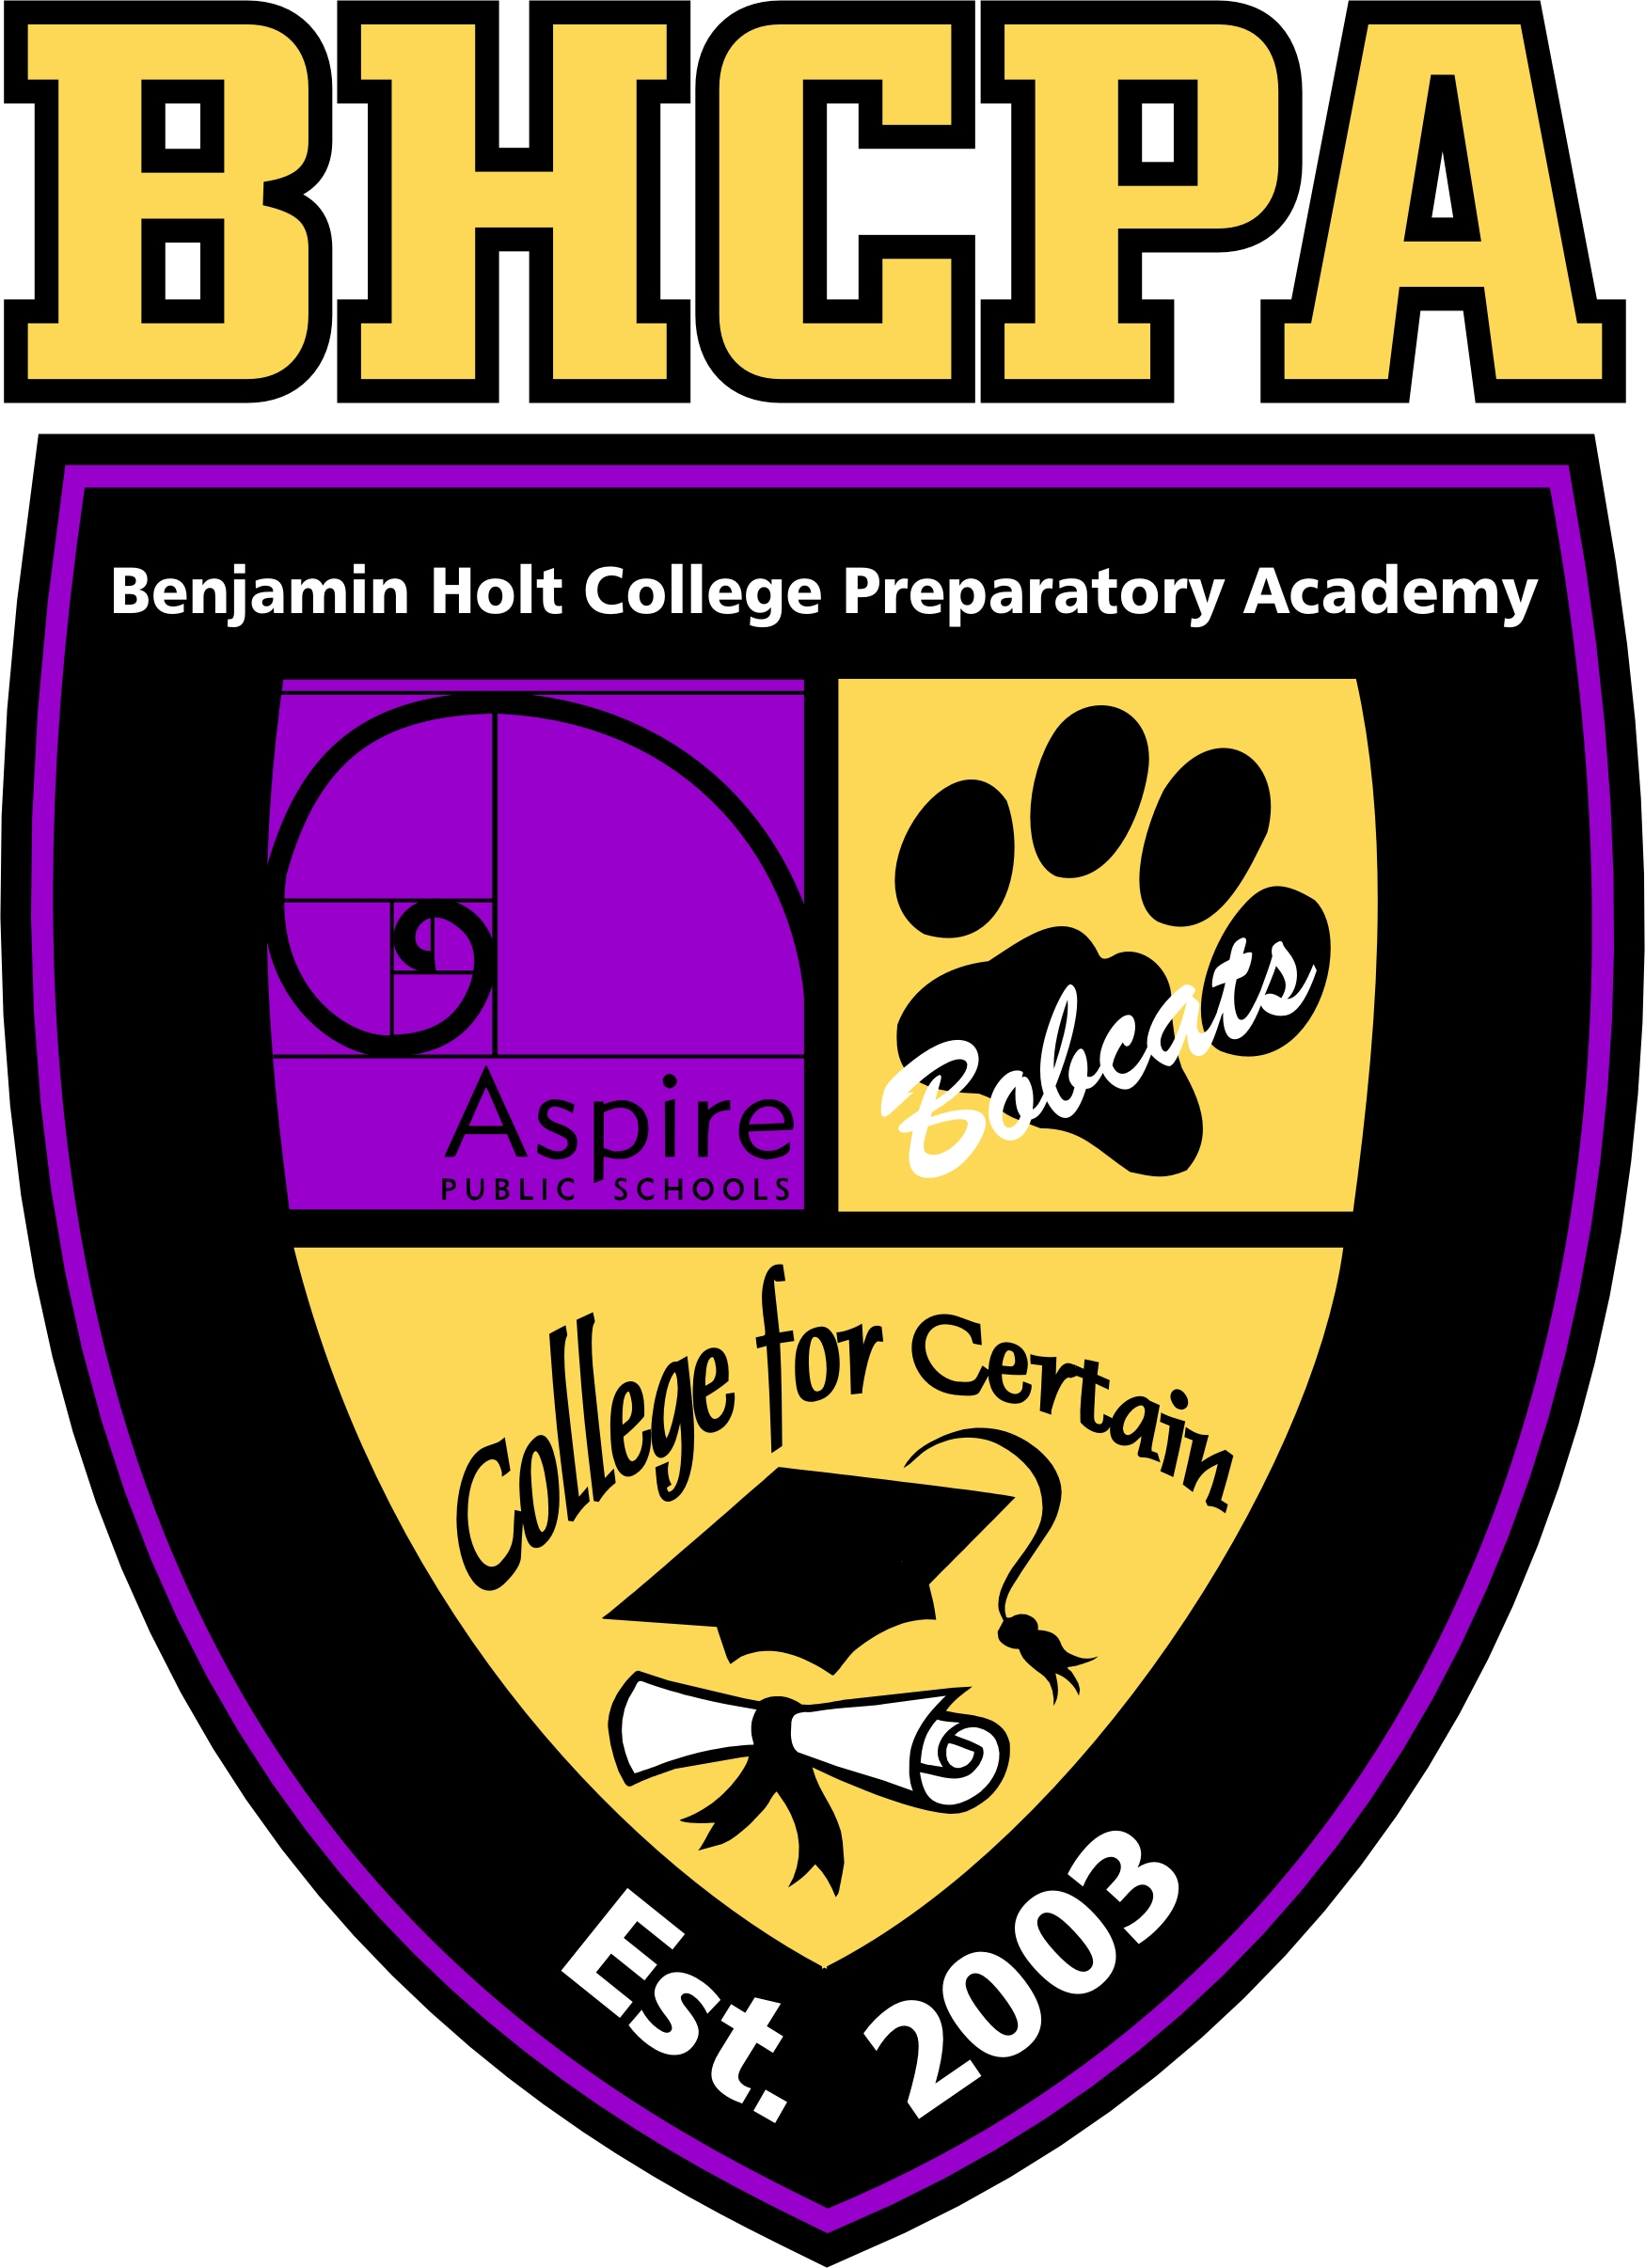
My Post- Secondary Success Plan
2-Year Pathway Part 2

Aspire Public Schools

Aspire Benjamin Holt College Prep Academy
Two- Year College Pathway: Part 2

Evaluation Questions
- Does the college you have selected accept the college classes you have taken with BHA (through Alliant International University, MiraCosta College, and San Joaquin Delta College)? _______________________________________
- Act as though you are an evaluations officer at the college. The task of an evaluations officer is to review transcripts/ classes from other colleges and determine whether or not they meet course equivalency of one of the courses taught at the college. MARK THIS OFF ON YOUR GENERAL EDUCATION AND MAJOR PATTERNS. Use the following page to help you.
  - DO THE BEST YOU CAN. IF YOU ARE NOT SURE, IT IS SAFER TO MARK THAT THE COURSE DOES NOT COUNT AS AN EQUIVALENT COURSE. In marking it as such, you will plan for more classes which will ensure you will still graduate on time versus finding out later that the course does not count and you are now short courses for graduation.
  - College systems determine equivalency in different ways.
    - If the course does count and the college accepts the college classes, it will be marked off that you have completed the course and have one less class to take for your major and/ or general education requirements
    - If you will have to refer to your college’s catalog to determine transferability, you will need to find the course description of the original course and find a course with almost the exact same description in the catalog of your school
    - If the course is not counted as an equivalent class but the college accepts the class, the course will be counted in the elective courses section
    - If the college does not accept the college classes, you are starting from ground zero

WHERE DO I GO TO FIND OUT TRANSFERABILITY?

 | Classes you took at:
If you applied/will be transferring to: | Delta College | MiraCosta College | Alliant International University
Community College | College catalog (of the college you will be attending) | College catalog (of the college you will be attending) | College catalog (of the college you will be attending)
CSU/UC | www.assist.org | www.assist.org | College catalog (of the college you will be attending)
Private/Out of State | College catalog (of the college you will be attending) | College catalog (of the college you will be attending) | College catalog (of the college you will be attending)

