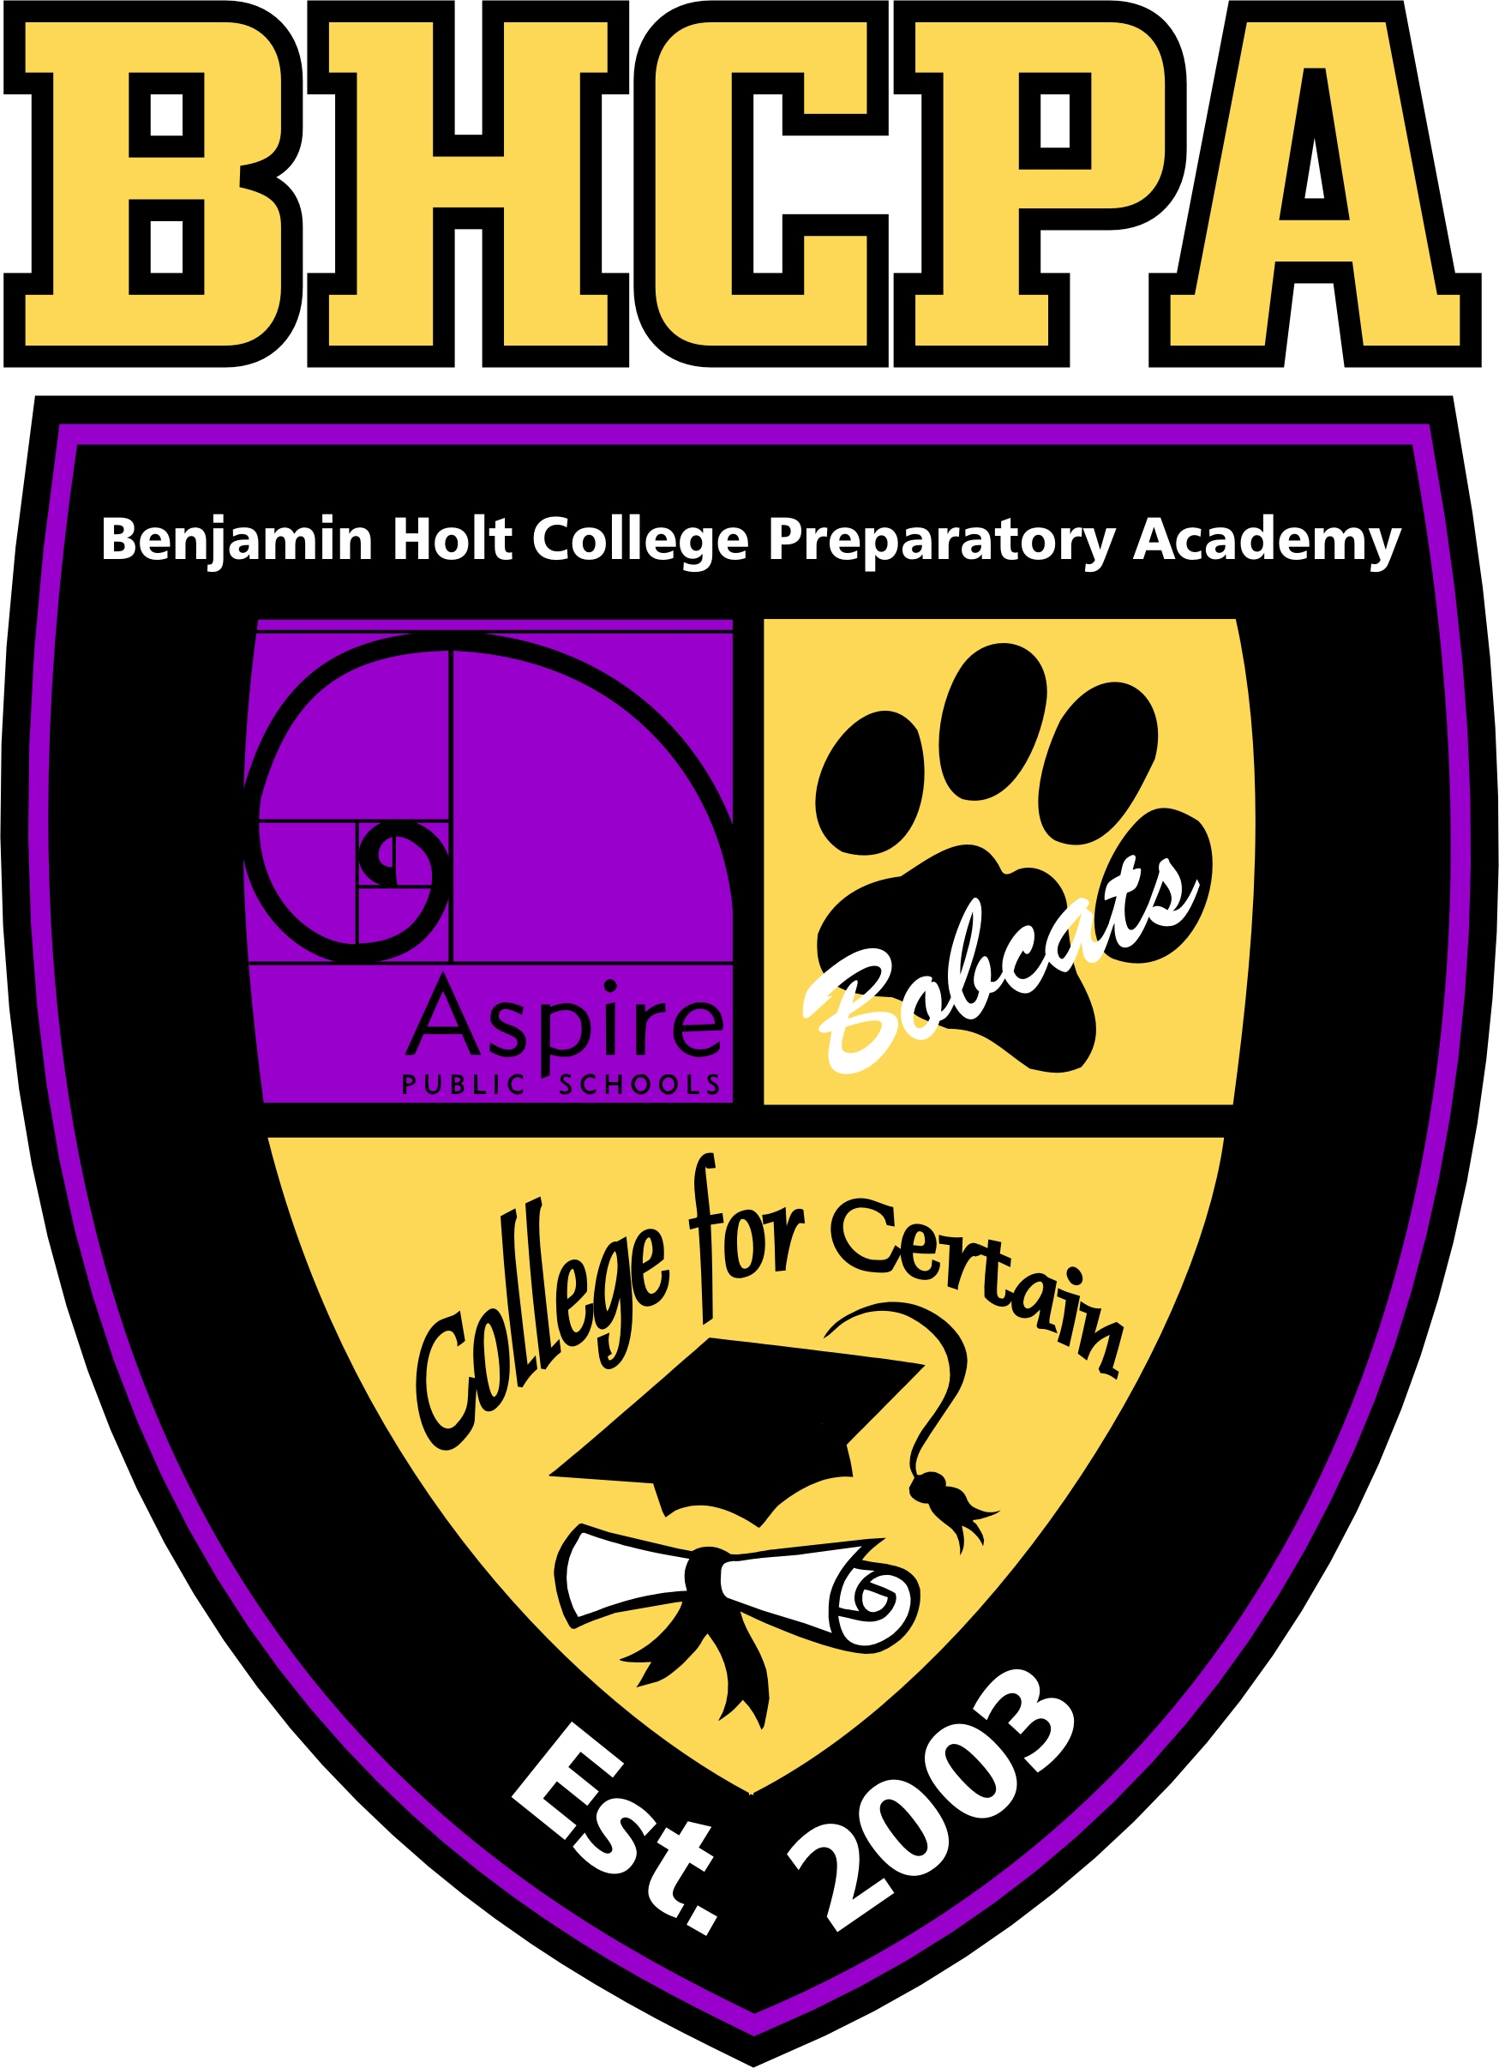
My Post- Secondary Success Plan
4-Year Pathway Part 1

Aspire Public Schools

Aspire Benjamin Holt College Prep Academy

My Post- Secondary Success Plan
Senior PSSP Report

Purpose

The intent of generating a PSSP is to assist each student in identifying what his/ her next steps and goals are for himself/ herself after graduating from high school. Creating this plan will help students identify post- secondary options of high interest, financial aid support for each option, financial earning implications of each, identify which option he/ she wishes to pursue, develop a backwards plan for matriculating successfully and on time, determine his/ her strengths and how he/ she will mobilize those strengths toward his/ her goals, and brainstorm possible hurdles he/ she expects to encounter and what his/ her plan is to overcome those obstacles.

Overview of PSSP Components

- PSSP Option
- Successful matriculation plan
- Strengths and goals
- Possible hurdles

Calendar of Completion
My PSSP Project will be graded by:
_______________________________

Due Date | Item | Tool | Points Earned
April 5th | Part 1  Units for graduation/  major | Part 1  PSSP Form  General Education pattern and major pattern | _____/20
April 12th | Part 2  Evaluation of transferability of courses | Part 2  General Education pattern and major pattern | _____/20
April 19th | Part 3  uAspire  (Shared Google Sheet) | Part 3  Attach uAspire  Award Analyzer | _____/20
April 19th | Part 4  Fall Schedule and Important Dates | Part 4  Placement Test Policy &  Scheduling Form  PSSP Form for dates | _____/20
April 26th | Part 5  Campus Resources  Matriculation Plan  Hurdles | Part 5  PSSP Forms | _____/20
________ I would like my final PSSP returned after it has been graded.

Four Year College Pathway
Student will utilize his/ her research skills and obtain the graduation requirement for his/ her chosen college and major. This includes general education requirement (also known as the breadth requirement) and major requirement. Students will then determine which classes he/ she still needs to complete (after accounting for those the student took at BHA) and generate his/ her first semester schedule of classes.

Tip from Alumni: Bookmark where you find your information. You will be surprised how often you refer back to this information!

Four- Year College pathway: Part 1
In order to graduate from college, students must complete a certain number of units, general education classes, and classes to fulfill the major requirement. Please answer the following questions and attach the general education pattern and major pattern for your graduation requirement based on your major and college choice to this document.

Graduation Requirements

Minimum Number of Units Needed to Graduate: __________ Units
How many are needed from general education? __________ Units
How many of the units are needed from your major? __________ Units

Degree Questions

- What is your major? ________________________________________________
- Are you also planning to have a concentration (a focus point for your major)? If yes, what is it? Not all majors will offer a concentration. If you do select a concentration, make sure to include those requirements as part of your major requirement. ________________________________________________________________________
- Are you planning to double major and/ or minor? If yes, please list the other major/ minor. Please include the course requirement for the additional major/ minor with this document. ________________________________________________________________________
- If you are going in undeclared, explain in detail the process and what that will look like for you. (i.e. when do you meet with your counselor, what paperwork needs to be submitted, deadline, etc.).

