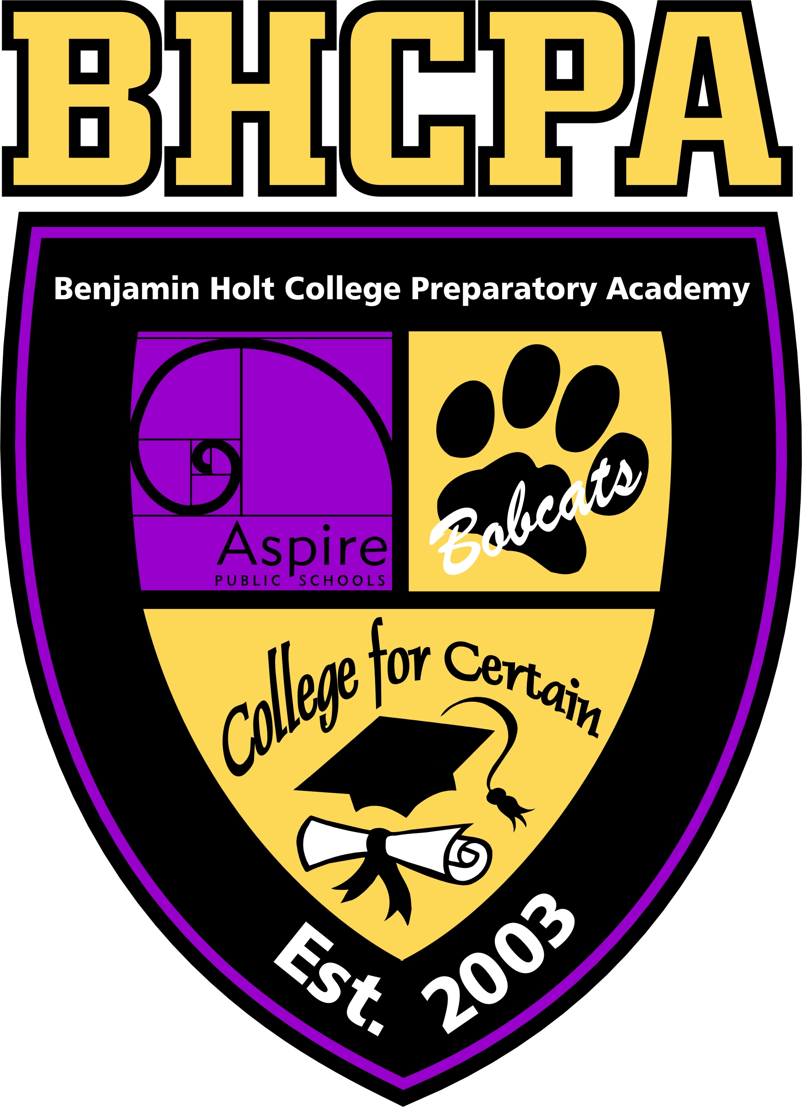
My Post- Secondary Success Plan
4-Year Plan Part 4

Aspire Public Schools

Aspire Benjamin Holt College Prep Academy
Four- Year College pathway: Part 4

Fall Term Schedule
Next you will be creating your fall schedule. If the course schedule for Fall 2019 is not available, use the schedule from Fall 2018.Create your schedule on https://freecollegeschedulemaker.com/ or create your own, print it and attach to this form. How many units will you be taking this fall term? ______.
Fall Term Dates
First day of Fall term/ first day of school: ______________________________
Last day to drop classes and receive full refund: ______________________________
Last day to drop classes without a “W”: ______________________________
Last day to drop classes with a “W”: ______________________________
Finals week: ______________________________
Last day of Fall term/ last day of classes: ______________________________

