Four- Year College pathway: Part 5
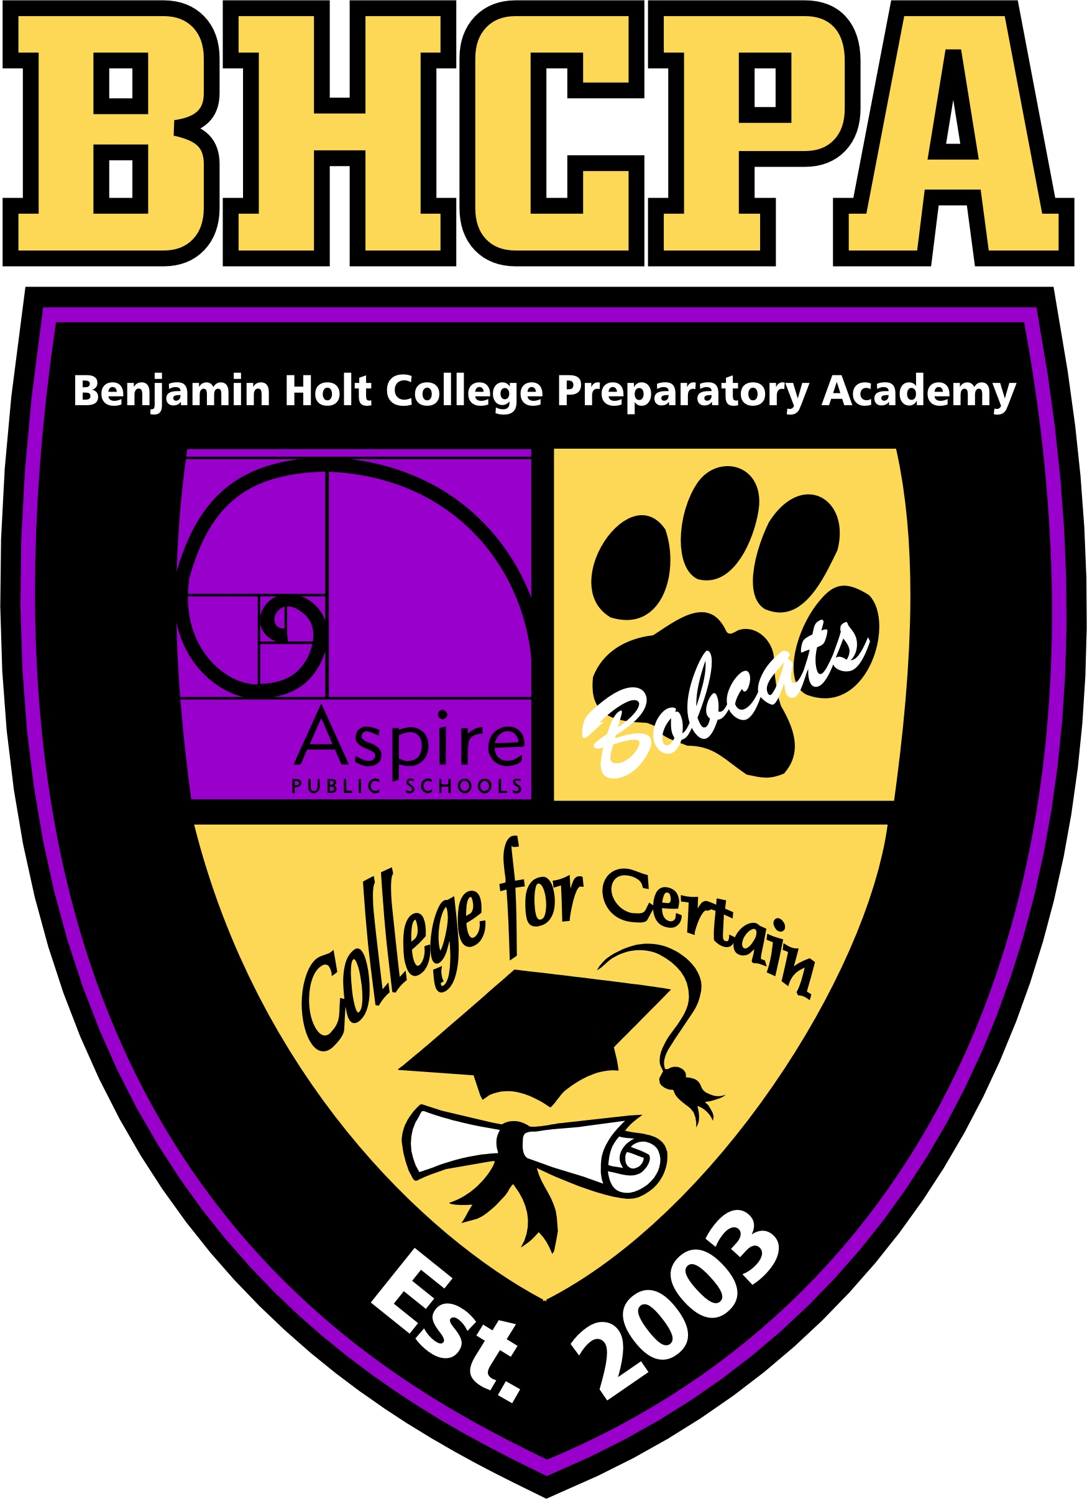
My Post- Secondary Success Plan
4-Year Plan Part 5

Aspire Public Schools

Aspire Benjamin Holt College Prep Academy
Campus Resources Complete the chart below for the college you are planning to attend. Feel free to add to the list of any other campus resources you believe may be useful or beneficial to you that is not already listed. Also, you will record what services are offered at each of the resources. Print a map and highlight the location of each campus resource. Attach the map.
Campus Resource | What type of services are offered at each resource? | Contact Information (i.e. phone number, email address, website)
Admissions and Records |  | Phone:  Email:  Website:
Financial Aid Office |  | Phone:  Email:  Website:
Tutoring Center |  | Phone:  Email:  Website:
Computer Lab |  | Phone:  Email:  Website:
Career Center |  | Phone:  Email:  Website:
Counseling Center |  | Phone:  Email:  Website:
Bookstore |  | Phone:  Email:  Website:
Library |  | Phone:  Email:  Website:

Additional Campus Resources

Campus Resource | What type of services are offered at each resource? | Contact Information (i.e. phone number, email address, website)
Phone:
Email:
Website:
Phone:
Email:
Website:
Phone:
Email:
Website:
Phone:
Email:
Website:
Phone:
Email:
Website:
Phone:
Email:
Website:
Phone:
Email:
Website:

Matriculation Plan
There are many variables that must be accounted for when discussing matriculation. Matriculation is defined as enrolling in a college/ university as a candidate for a degree (Dictionary.com). For the purpose of this PSSP report, the matriculation plan will encompass college going students, students planning to attend a military branch, students whose goal is to go straight to the workforce, and so on. In essence, this matriculation plan is the student’s plan for how he/ she is going to achieve his/ her goal as set by his/ her choice of the PSSP option.

List the important dates you will need to make sure you are aware of for this plan from aPRIL until the end of August. what taskS must BE completeD (i.e. confirm which college I will attend in the Fall of 2019, accept financial aid package, orientation, meet with a counselor, ATTEND A job fair, and/ or meet with recruiter).

APRIL 2019
Date | Activity
MAY 2019
Date | Activity
JUNE 2019
Date | Activity
JULY 2019
Date | Activity
AUGUST 2019
Date | Activity

List any other important dates you must remember after August 2019 in order to keep going in the direction you desire.

DATE | ACTIVITY

Brainstorm possible hurdles you expect to encounter and what your plan is to overcome those obstacles - think academic, social/emotional (i.e. homesick), living arrangements (problems w/roommates, tired of meal options in dining commons, run out of funds for meal plan) – the problems you hear about in movies, blogs, people you know in college, how would you resolve them?

Welcome to the Next Chapter of Life
Thank you for creating your post- secondary success plan. Please keep in mind that plans are just that- plans. They may change depending on life circumstances. However, in creating the plan, you now have a direction once you leave BHA. It is our hope that this plan will keep you on track to reach the goals you have set for yourself.

