My Post- Secondary Success Plan
Part 1

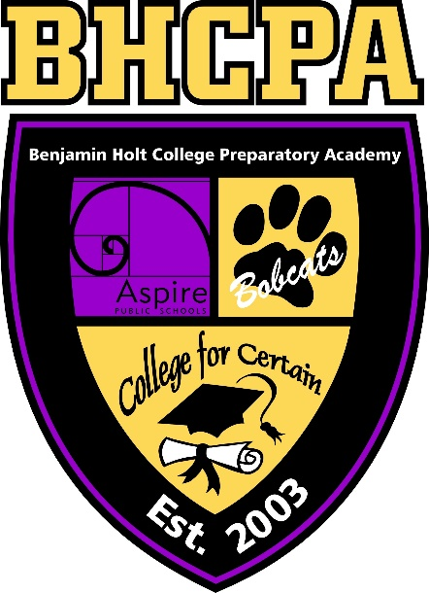

Aspire Benjamin Holt College Prep Academy

My Post- Secondary Success Plan
Part 1

Purpose

The intent of generating a PSSP is to assist each student in identifying what his/ her next steps and goals are for himself/ herself after graduating from high school. Creating this plan will help students identify post- secondary options of high interest, financial aid support for each option, financial earning implications of each, identify which option he/ she wishes to pursue, develop a backwards plan for matriculating successfully and on time, determine his/ her strengths and how he/ she will mobilize those strengths toward his/ her goals, and brainstorm possible hurdles he/ she expects to encounter and what his/ her plan is to overcome those obstacles.

Overview of PSSP Components

- PSSP Option
- Financial forecast
  - Financial aid support
  - Financial earning implications
- Successful matriculation plan
- Strengths and goals
- Possible hurdles
Calendar of Completion
My PSSP Project will be graded by:
_______________________________

Due Date | Item | Tool | Points Earned
April 8th | Part 1  Resume  Letter of Interest (cover letter) | Part 1  Please reach out to Dr. Woodruff for tips on how to write a resume/cover letter. | _____/20
April 12th | Part 2  The Interview  Interview Reflection Questions | Part 2  Schedule an interview in advance with Dr. Woodruff. | _____/20
April 19th | Part 3  Developing a Plan  Job Tracker Form | Part 3  Use link provided in document. | _____/20
April 19th | Part 4  Financial Log | Part 4  Use excel spreadsheet that is embedded in document. | _____/20
April 26th | Part 5  Matriculation Plan | Part 5  Backwards Map using the charts provided or your own planner. | _____/20
________ I would like my final PSSP returned after it has been graded.

Workforce Pathway
Student will utilize his/ her research skills and obtain requirements to join the workforce.

Student will create:
Letter of Interest (Cover Letter)
Resume
Participate in a Mock Interview
Develop a Plan

Tip from Alumni: Bookmark where you find your information. You will be surprised how often you refer back to this information!

Workforce Pathway: Part 1

Please discuss your reasons and passion for why you choose this plan.

How much will this plan cost you? Calculate all costs utilizing budget form on the Excel spreadsheet here from CollegeInColorado.org (https://www.cicmoney101.org/Calculators/Budget-Worksheets/Traditional-College-Student.aspx)

How do you plan to cover the cost of this plan? Be specific and include timelines (i.e. obtain a job by the end of July).

The Workforce

Finding a job is not always as easy as one would like it to be. In preparation to look your best on paper and in person on interviews, complete the following tasks.

Letter of Interest (also known as a Cover Letter) and Resume

One of the first impressions of you is what your potential employer reads on your letter of interest (cover letter) and resume. Therefore, it is important that your documents are nicely laid out, easy to read, and encompasses words and phrases that are relevant to the job you are applying for. Of course, this means your letter of interest and resume will need to be adjusted every time you apply to a new position. A general letter of interest and resume may be created and then adapted as needed.
Using San Joaquin Delta College’s Employment Preparation Portfolio as a guide (you may use others that you feel is more appropriate and tailored to you), generate a generic letter of interest and resume. These documents will serve as your foundation employment documents which will be altered as needed when you apply to different jobs.

