My Post- Secondary Success Plan
Part 2

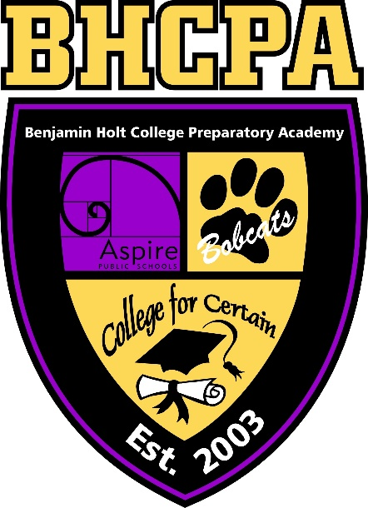

Aspire Benjamin Holt College Prep Academy

Workforce Pathway: Part 2

The Interview

The letter of interest and resume will get you through the door, but it will be how you interview that will determine if you are hired or not. Schedule a mock interview with Dr. Woodruff using the guiding information in the Delta College Employment Preparation packet. Treat this interview as if it is the real thing, meaning you must dress professionally and come prepared. Once you are done with your mock interview, answer the questions on the following page. Make sure to get feedback from Dr. Woodruff after the interview to help you know how to improve in the future.

Interview Reflection

How did you feel during the interview?

How did you feel after the interview?

What did you do to prepare for the interview?

What did you feel you did well in?

How could you improve for the next interview?

What feedback did your interviewer give you?

