My Post- Secondary Success Plan
Part 3

Aspire Benjamin Holt College Prep Academy

Workforce Pathway: Part 3

Developing a Plan

Deciding to join the workforce directly out of high school may be challenging.
What is your plan to ensure you will be able to support yourself besides “getting a job”?

What type of job are you looking for? What jobs are you applying for?

What resources are you utilizing to help you find jobs?

What is your timeline for obtaining a job?

Reflecting back on your Expense spreadsheet from your PSSP options, is the kind of job you are looking for going to be sufficient financially? If not, how do you plan to address that? If it is, will it be enough to allow you to live comfortably?

How do you plan to manage your expenses until you obtain a job?

What does your future look like with type of job you are planning to acquire? Will you be able to support yourself and a family? Will you need to return to school?

Is this a short term plan until you decide what it is that you are going to do? Is this a long term plan and you plan to move your way up the chain of command? If so, where do you want to be on the chain of command? What does it require academically and experience wise?

What have you done thus far to be a member of the workforce? Do you already have a letter of interest and resume completed? Have you applied to jobs? If so, which ones? Have you utilized your resources (i.e. WorkNet)?

As you are applying for jobs, use this sheet to track which jobs you applied to and the results.
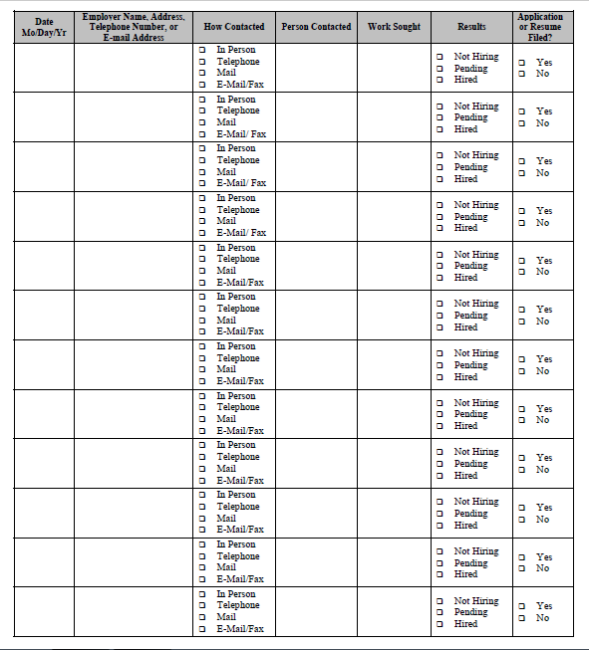
Source: https://images.template.net/wp-content/uploads/2016/07/27085035/Work-Log-Template.pdf

As you are applying for jobs, use this sheet to track which jobs you applied to and the results.
Source: https://images.template.net/wp-content/uploads/2016/07/27085035/Work-Log-Template.pdf

Are you already working? Are you planning to remain at your job for the foreseeable future? If so, answer the questions below. Have a conversation with someone in management in your company to answer some of these questions. Specify who you spoke with and their job title.

Where do you currently work? What is your job title? What are your duties?

What is the highest level of management you can achieve at your current job?

What do you need to do in order to get to this level? What education experience do you need? What is the amount of pay?

What is the highest level of management you can achieve with only a high school diploma? What do you need to do in order to get to this level? What is the amount of pay?

