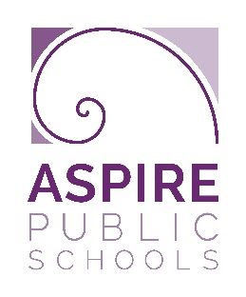
Benjamin Holt College Prep Academy
Commitment to Community 2019-2020
Community Hour Log
Please visit www.benholtschool.org for volunteer opportunities
This form must be filled out completely prior to submission. In order for the hours to count toward your Commitment to Community Award, you must have this form completed and turned in by the deadline. You must use a new form for each organization.
25 hours due by 1/10/20 Next 25 hours due by 3/12/20 Final 25 hours due by 5/15/20
Name: _______________________________________ Class of (circle one): 2020 2021 2022 2023
Advisory Teacher: ______________________________ Your Email: __________________________________
Name of Service Organization: _________________________________________________________________
Description of Service Provided:
Community Service Log:
Service Date | # of hours served | Service Performed | Supervisor’s Signature

Service Director/ Sponsor Information
All hours will be verified.
Name: | Daytime Phone:
Email: | Other Phone:
Signature: | Date:

